

**END OF TERM ONE EXAMINATIONS 2023**

**TOP CLASS**

**HEALTH HABITS**

NAME_______________________________

1. Write any **one** member of a family.
2. Mention any **two** things we get from a cow.
3. **Name these things used to clean the body**

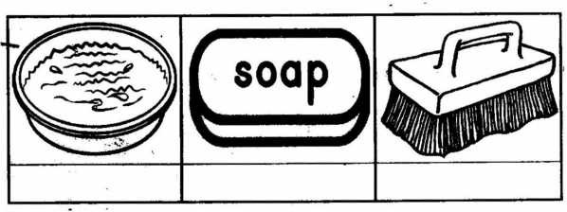

1. **Match correctly.**

policeman workshop

market vendor garden

farmer police station

carpenter market

1. 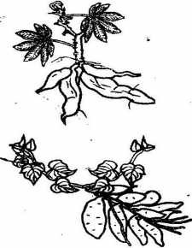**Name this food we eat at home**



sweet potato plant



cassava plant

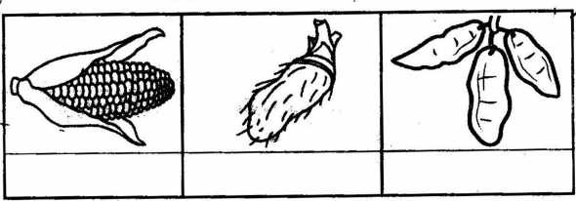

1. **Name these animals**.

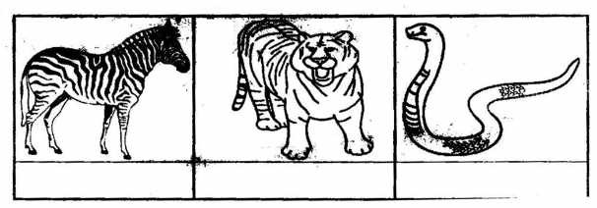

1. **Match correctly.**
2. **Name these types of weather**.

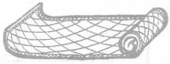

(a)

for

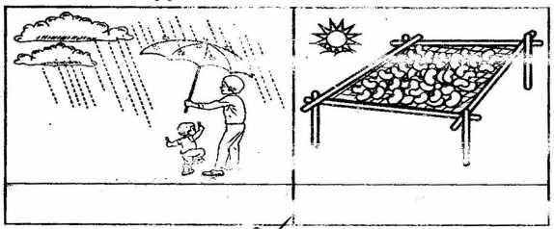

1. **Name these things we find in the sitting room.**

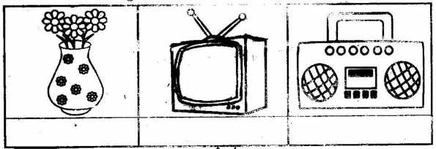

1. **Give the uses of the following**:

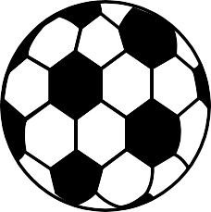



(b)



for